EXP NO: 02 Windows Registry Forensics NAME : ADHIYAN PERIYAR R P

DATE: 17/07/2025 ROLL NO : 2319010202

AIM :

Introduction to Windows Registry Forensics

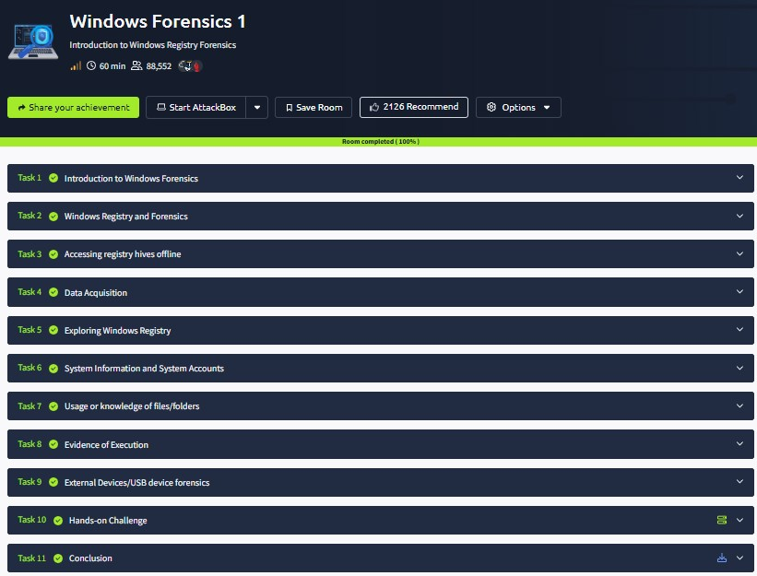

Task 1 : Introduction to Windows Forensics

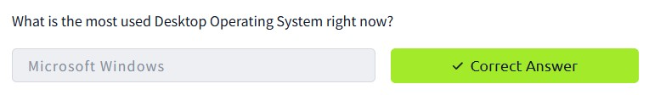

Task 2 : Windows Registry and Forensics

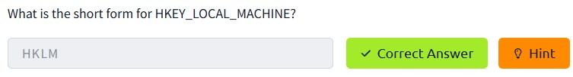

3 Accessing registry hives offline

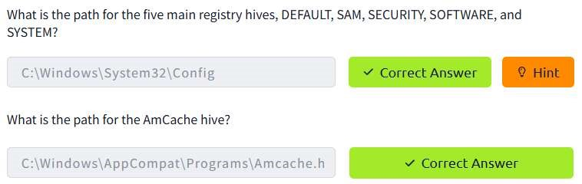

Task 4 : Data Acquisition

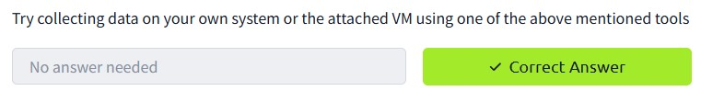

Task 5 : Exploring Windows Registry

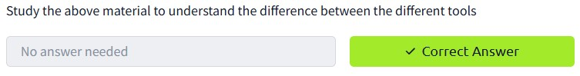

1. System Information and System Accounts

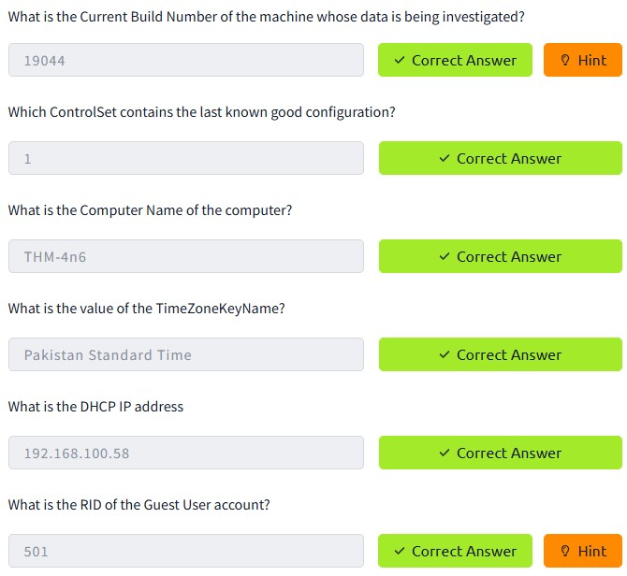

1. Usage or knowledge of files/folders

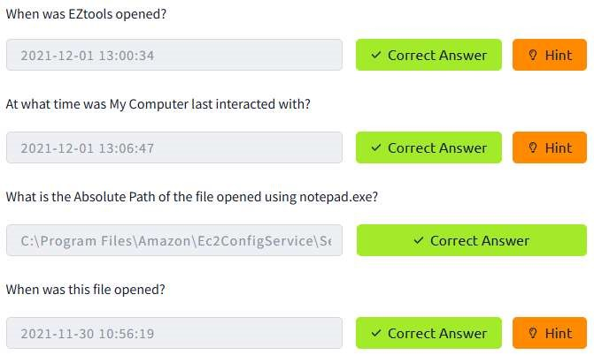

Task 8 : Evidence of Execution

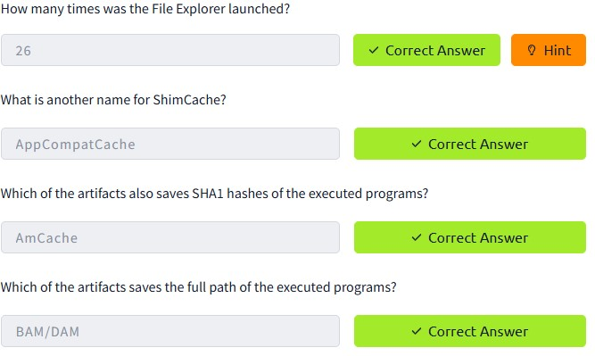

9 External Devices/USB device forensics

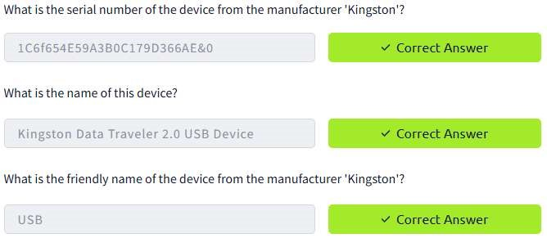

Task 10 : Hands-on Challenge

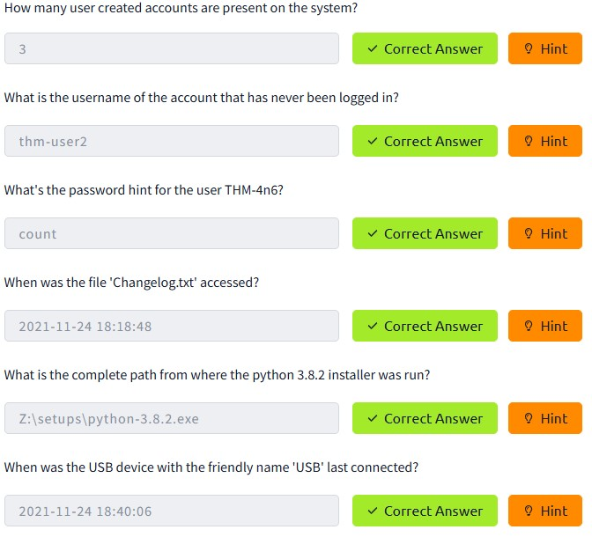

RESULT :

Windows Registry Forensics is successfully completed in tryhackme platform